Northwest Connection Family Resources

Spring Tribal Conference
Building Your Bounce: Promoting Adult Resilience

Friday - April 28,2023
Sevenwinds Casino, Lodge & Convention Center – Hayward, WI

Registration 8:00 am
Conference 8:30 am – 3:30 pm
Continental breakfast & Lunch provided

Developed by the Devereaux Center for Resilient Children, this training supports caregivers in recognizing the importance of their own resilience and how it relates to their ability to provide quality care to youth. Areas of focus include understanding characteristics of resilience, protective factors, and risk factors; utilizing the Devereaux Adult Resilience Survey (DARS), a self-assessment; and exploring everyday strategies for strengthening resilience.

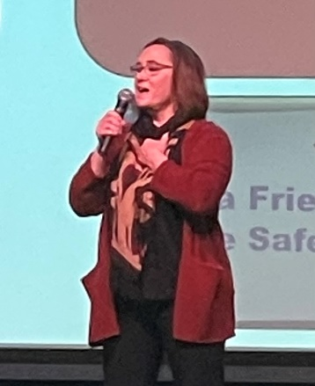
MEET THE TRAINER – back by popular demand:
Amy Foster Wolferman, M.Ed, Director of School-Based Training and Technical Assistance for the National Native Children’s Trauma Center provides training and technical assistance to educators, school leaders, families, and community members in trauma resilient school systems and practices, secondary traumatic stress interventions, Positive Behavioral Interventions and Supports (PBIS), bullying prevention and suicide prevention. Ms. Foster Wolferman’s primary area of focus is helping schools support the social and emotional needs of students impacted by trauma. She co-authored the Bounce Back for Classrooms trauma-focused social skills curriculum; developed a trauma-informed systems-change model, Trauma Resilient Schools with NNCTC colleagues; and co-wrote the Walking the Four Directions: Traditional View of Discipline trainer’s manual. In addition, she has served as an Implementation Specialist in Multi-Tiered Systems of Support (MTSS) for schools; has a background in teaching, early childhood education, special education, and working with youth in the outdoors; and is certified as a trainer in the Applied Suicide Intervention Skills Training (ASIST), Suicide Alertness for Everyone (safeTALK), and the Steps to Respect Bullying Prevention Program.
Northwest Connection Family Resources
Spring Tribal Conference
Friday - April 28, 2023
How well do you bounce?
How well do you support children’s bounce?

One registration per person. (Please make copies if needed.) Registration Deadline April 7th.

Name________________________________________________________________
Program or School District_______________________________________________
Address__________________________________County/Tribe_________________
City_____________________________________ State _________Zip ____________
Phone ______________________Email _____________________________________
Registry # ____________________ OR birthdate _______________ & last 5 digits of your social security number__________________(required to complete registration)
Conference fee $30.00 Groups of 5 or more $25.00 each

Please send your completed registration form to the address below or register online at https://forms.gle/81TsWmtzDanrMnwT9.
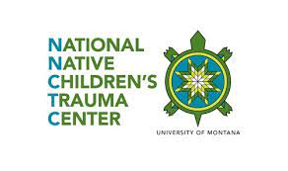
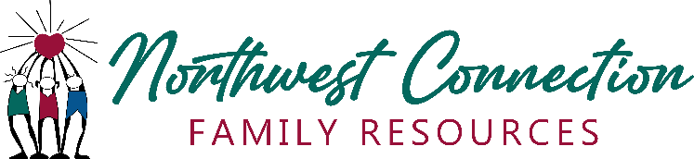

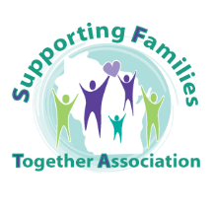

15896 W 3rd Street Hayward, WI 54843 (715) 634-2299 (800) 733-KIDS
wisconsinchild.org

