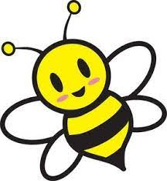
“BEE our Guest”
SPECIAL EVENT-Diaper Bank
When: Saturday, April 1, 2023
Time: 10:00am – 2:00pm
Where: Northwest Connection Family Resources (NCFR)
15896 W 3rd Street, Hayward, WI 54843
Come “BEE our Guest” and stop in for FREE diapers.
TOUR THE CENTER and learn about our programming
(Two packages of diapers/wipes per family/per child)

April is Family Strengthening Month  First 100 families will receive a FREE “Parenting on the Go” Bag!  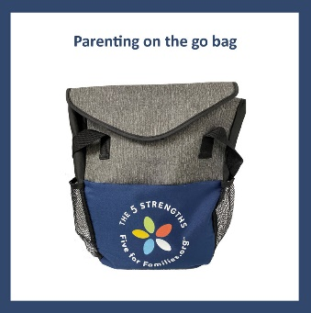  These on-the-go bags include activities that promote parent-child interactions during appointments & outings.  (bags over $100 value) | FREE Car Seat Clinic  Have your child’s car seat checked by a Certified NCFR  CARSEAT TECHNICIAN  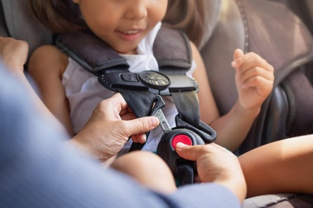
SNACKS 10:00 – 11:30 AND 1:00 – 2:00
SLICE OF PIZZA 11:30 – 1:00

DON’T FORGET TO ENTER FOR GREAT DOOR PRIZES
INCLUDING A $100 Gas Card from Kwik Trip

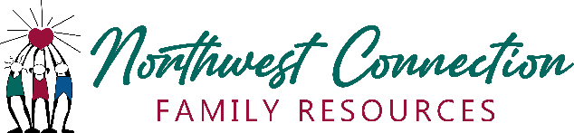

A special “thank you” to Grace Lutheran Church for your support to help families including keeping kids safe, while in vehicles, in our community.

