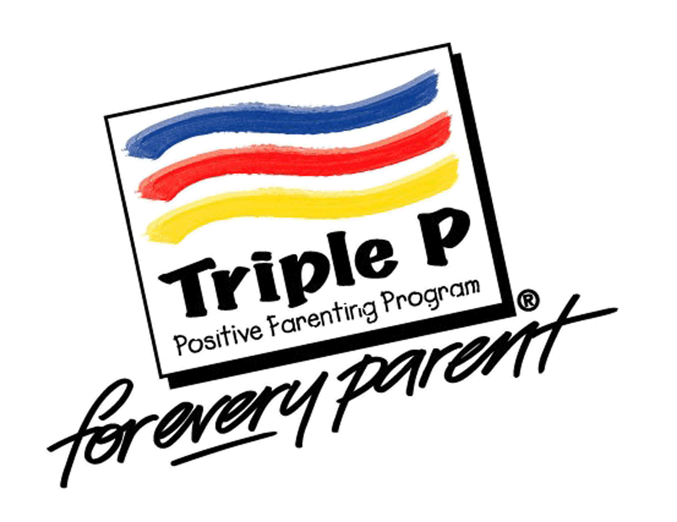
Triple P Workshop: Hurting Others
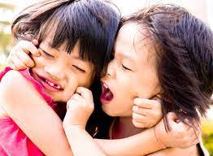
Does your child hurt others by biting, pulling hair, pushing, scratching, or hitting? This can become frustrating and embarrassing for caregivers when dealing with these behaviors in public. Come learn why these behaviors happen, how to prevent them from happening, and how to manage them if they do happen.

When: Tuesday, January 31st, 2023
Where: Zoom (Link will be sent day of workshop)
Time: 6:00pm – 7:30pm
To register, click on the link https://forms.gle/uTYxDft88g9F6EKg8
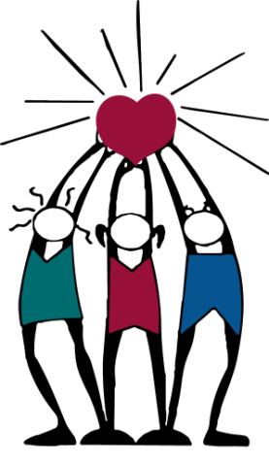
attached to this post or call 715-634-2299
by Thursday, January 26th, 2023.

