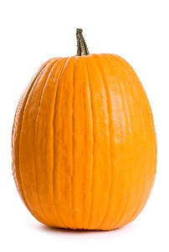
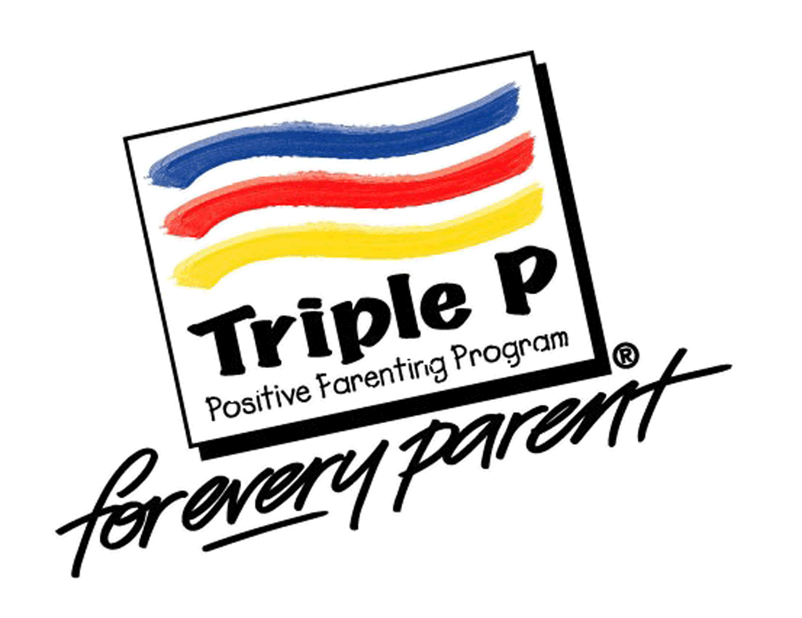
Pumpkin Painting and Triple P Workshop:
Hassle-Free Mealtimes with Children
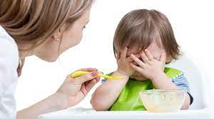

While mealtimes can be one of the most difficult times for parents, with a little planning, they can become enjoyable for the whole family. Come hear suggestions to help you encourage the type of mealtime behavior you want to see, reduce mealtime behavior problems and fussiness, and make mealtimes easier on you as a parent.

When: October 28th, 2022
Where: Northwest Connection Family Resources
15896 W 3rd Street
Hayward, WI 54843
Time: 9:00 – 10:30 am
Pumpkin Painting at 10:30 am
(must attend the workshop to paint pumpkins)
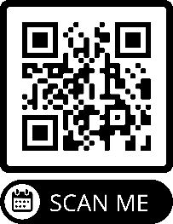
Limited to first 20 registrations
https://forms.gle/kteWkzRoTWbFyAX67
To register, click on the link attached to this post or call
(715) 634-2299 by Friday, October 21st, 2022.

