Early Childhood Teacher Book Study
Northwest Connection Family Resources
15896 West 3rd Street
Hayward, WI 54843
800-733-5437
4 Thursdays - Beginning Sept. 22nd
5:45pm-7:15pm
Join us as we read "Play: The Foundation of Children’s Learning,” written by Lisa Murphy. Discover why play is school readiness with this updated guide. Timely research and new stories highlight how play is vital to social, physical, cognitive and spiritual development of children. Learn the seven meaningful experiences we should provide children with every day and why they are so important!

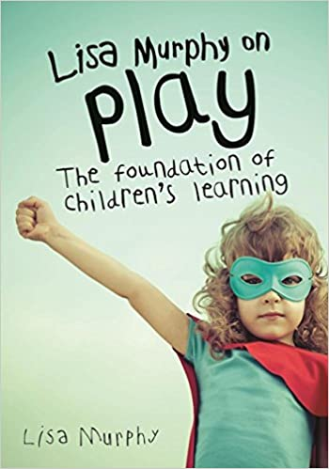
A book study is a way for a group of people (in this case, early childhood teachers) to come together to have meaningful conversation with one another. It will be an opportunity to engage with one another on thoughts, reflections and new ideas from the readings and how they can apply to your teaching goals. Please join us for a reading of “Play: The Foundation of Children’s Learning.”

How do I participate? You will be sent a Zoom link for each week of discussion, we ask that you have your video on for the discussion if you are able.

What is my obligation for attendance? Full participation in all Zoom sessions and reading the assigned chapters is required. There will be a short survey after each session as well as a short assignment to turn in after the final session (you will have time to work on this during our final session). Upon completion, you will receive 10 hours of credit through The Registry.

What are the dates/times? Thursday, September 22nd 5:45pm-7:15pm (Discuss Pages 1-53)
Thursday, October 6th 5:45pm-7:15pm (Discuss Pages 57-100)
Thursday, October 20th 5:45pm-7:15pm (Discuss Pages 101-149)
Thursday, November 3rd 5:45pm-7:15pm (Discuss Pages 150-192)
**Audio links will also be shared of Lisa Murphy reading the book once registration is confirmed**
Do I have to pay for the book? The book will be provided for FREE if you attend all sessions and fully participate.
(If you do not attend all sessions, we will send an invoice for the cost of the book - approximately $22.00)

By when do I need to Register? No later than Thursday, September 8th so that we have time to ship you a book and time to read before our first session.

How do I register?

A confirmation email and schedule for each session will be emailed to you upon registration
and a book will be mailed to the address you provide.

