Sawyer County –
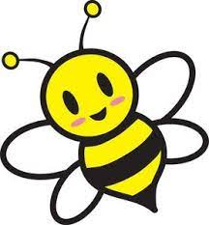
“BEE our Guest”
FREE Diaper Bank
When: December 19, 2022
Time: 12:00 – 6:00 p.m.
Where: Northwest Connection Family Resources (NCFR)
15896 W 3rd Street, Hayward, WI 54843

Come “BEE our Guest” and stop in for a
FREE package of diapers.

While you’re here TOUR THE CENTER and check out the fun activities and information:
- Family Project Table
- Snack Table
- Free Children’s Book and Book Bag
- NCFR Programming Information
- Car Seat information, installations, on-site safety checks
- Free child care referral
- Learn how to become a certified provider
- Get connected to other community resources
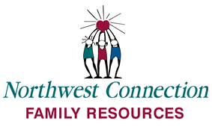
- Meet the NCFR staff

SIGN UP TO WIN GREAT DOOR PRIZES INCLUDING GAS CARDS, DOLLAR TREE GIFT CARDS, CHILDREN’S TOYS and more!
(two packages of diapers per family/per child)

