NORTHWEST CONNECTION FAMILY RESOURCES
Annual Fall Child Care Provider Conference
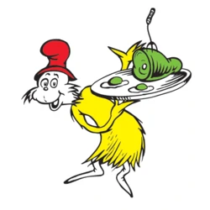
Let’s Talk Green Eggs and Ham!

Alonzo Kelly
October 22, 2022
Registration begins 8:00 am
Coffee & Networking 8:00 – 9:00 am
Conference 9:00 am – 4:00 pm

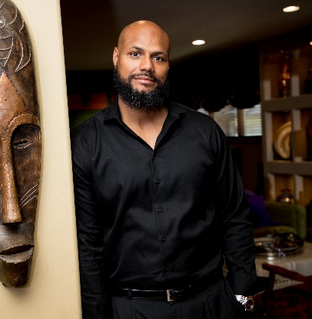
Born and raised in Detroit, MI, Kelly migrated to Wisconsin to attend St. Lawrence Seminary High School. Molded in the home of a loving grandmother and groomed in an institution of faith, his passion for service and leadership is unparalleled. He is the architect behind the first Teen Court Juvenile Correction Program for the state of Wisconsin, and has extensive leadership experience in the nonprofit, healthcare, and financial industry.
A dynamic Executive Coach, Professor, 3x Best Selling Author, and Radio Host, Alonzo Kelly has gained international and global attention as a premier consultant and strategist. Alonzo is recognized as one the nation’s leading experts on leadership development, strategic thinking, planning, and acting which results in individual and organizational goal achievement.

He has appeared on America’s Premier Experts which airs on major networks across the country including ABC, NBC, CBS, and FOX. Alonzo has served over 1,000 individuals through personal and professional development, delivered training to a plethora of Fortune 500 Companies, College and Universities, Institutions of Higher Learning, Foreign Countries (Netherlands, Belgium, Canada, Guam), nonprofit organizations, and is consistently retained to be the keynote speaker at large and small events across the country.

He holds a bachelor’s in Accounting, three master’s degrees (Public Administration, Human Resource & Labor Relations, Business Administration), and is nearing completion of a PhD in Multidisciplinary Human Services. In addition, he was recently awarded an honory Doctorate from the Trinity International School of Business.

WELCOME & ANNOUNCEMENTS

Navigating Change Without Losing Our Sanity

Green Eggs and Ham is a children's book by Dr. Seuss, first published on August 12, 1960. As of 2019, the book has sold 8 million copies worldwide. Why has a children’s book remained in such high demand? Perhaps it is because this book is purchased by more adults, professors, and professionals than any other demographic. We will use the plethora of lessons from this ‘simple’ book as a guide for assistance with evolving our thinking, communication, and actions which results in an increase of authentic relations with our peers, clients, students, and community partners.

MORNING SESSION:

The Art of Asking Better Questions
Part 1: How the Right Questions Lead to More Efficient and Effective Outcome

This full participatory presentation is designed to assist in creating an inter-culturally inclusive work environment for all. This learning journey will focus on the Professional Development of participants aimed at increasing knowledge and ability to utilize critical thinking skills to make authentic inquiry, apply appropriate meaning to terms and phrases, problem solve, communicate confidently, and foster more collaborative work environments rooted in authentic relationships.

LUNCH & NETWORKING

AFTERNOON SESSION:

Part 2: The Intersection of Lived and Learned Experiences on Civility in the Workplace

The impact of up to five generations working side by side in the workplace presents a plethora of experiences that can evolve and challenge authentic relationships. Each generation has a unique experience and understanding of the concept of respect, hard work ethic, and civility. How each of these are defined will influence how individuals recognize and respond to the world around them. As we become more intentional about shared definitions we are more inclined to actively participate in contributing to a desired Organizational Culture.

DOOR PRIZES & FINAL ANNOUNCEMENTS

AUCTION WINNER PICK-UP

Connect with friends over morning coffee and treats.

Conference vendors Blind Auction Lunch time chats

Door prizes Give-aways Games FABULOUS presenter

-------------------------------------------------------------------------------------------------------------------
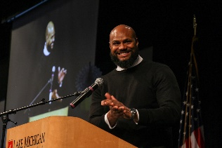
Let’s Talk Green Eggs and Ham!
Hayward Wesleyan Church
October 22, 2022 9:00 am – 4:00 pm
Cost: $35.00 before September 15, 2021
$45.00 after September 15, 2021
(Payment can be made by PayPal or check)

(Registration will be accepted until October 10, 2022 or until the conference is full)

To Register online: https://forms.gle/1yULpJnT5mUoANzd9

To Registry by email: Email nwconnection@ncfrwi.net One form per person.

To Register by phone: (800) 733-KIDS

Name: __________________________________________ Registry # ___________________

Program Name: ___________________________________ Phone # ____________________

Address: ________________________________________ County/Tribe: ________________

Email: ___________________________________________ YS rating: ____________________
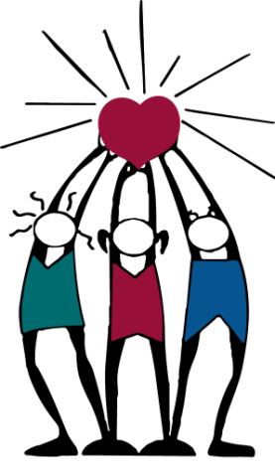
Northwest Connection Family Resources Bring a non-perishable food item to be donated
15896 W 3rd Street to local families and be entered into a drawing.
Hayward, WI 54843 $100 Lakeshore gift certificate
www.wisconsinchild.org
(Up to 10 entries – 1 entry per item)

