Northwest Connection Family Resources
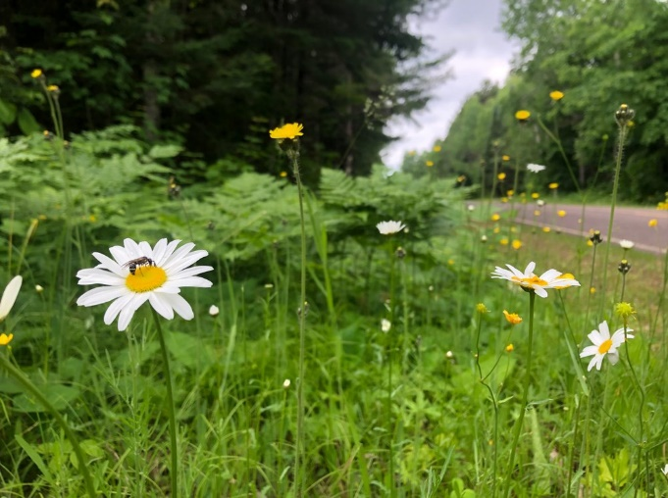

Spring Tribal Conference
Friday - April 29,2022
Sevenwinds Casino, Lodge & Convention Center – Hayward, WI

Registration 8:30 am

Trauma and Resiliency in Tribal Communities
9:00 am – Noon
In this introductory course about trauma and resilience participants will learn to observe the world through a trauma lens. The course provides an overview of research on trauma and discusses its relevance for American Indian/Alaska Native people and tribal communities. Participants will learn the varying types of trauma people experience, the impacts of trauma on the developing brain, and how trauma influences emotions, thinking, and behavior. The heart of this training is to create power through naming experiences and share strategies to promote individual and collective resilience within tribal communities to counter the effects of trauma. Example strategies shared will be specific to early childhood settings.

Lunch provided. Noon – 1:00 pm
Secondary Traumatic Stress and Self-Care
1:00 pm – 4:00 pm
This training honors the experience of people in helping roles professionally and personally who are regularly exposed to the traumatic experiences of others. Participants will learn the definitions and concepts for secondary traumatic stress (STS), burnout, and compassion fatigue, as well as consider individual and organizational factors that contribute to the experience of negative symptoms. Participants will participate in wellness activities and develop self-care plans designed to prevent and/ or reduce symptoms of STS.

MEET THE PRESENTERS:

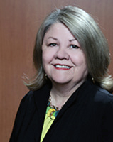
An enrolled member of the Assiniboine-Sioux Tribes of the Fort Peck Reservation, Dr. Marilyn Bruguier Zimmerman was the NNCTC’s founding Director. After serving as Senior Tribal Policy Advisor for the U.S. Office of Juvenile Justice and Delinquency Prevention, Marilyn returned to the NNCTC in 2016 as Senior Director of Policy and Programs. A pioneer in the facilitation of trauma-informed tribal system change, Marilyn has provided expert testimony to Congress and been appointed to numerous national task forces, including the Attorney General's Advisory Committee on American Indian/Alaska Native Children Exposed to Violence.
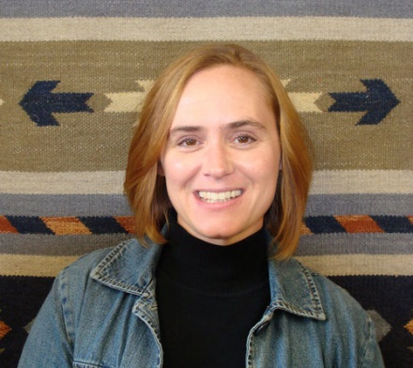
Amy Foster Wolferman, M.Ed, Director of School-Based Training and Technical Assistance for the National Native Children’s Trauma Center provides training and technical assistance to educators, school leaders, families, and community members in trauma resilient school systems and practices, secondary traumatic stress interventions, Positive Behavioral Interventions and Supports (PBIS), bullying prevention and suicide prevention. Ms. Foster Wolferman’s primary area of focus is helping schools support the social and emotional needs of students impacted by trauma. She co-authored the Bounce Back for Classrooms trauma-focused social skills curriculum; developed a trauma-informed systems-change model, Trauma Resilient Schools with NNCTC colleagues; and co-wrote the Walking the Four Directions: Traditional View of Discipline trainer’s manual. In addition, she has served as an Implementation Specialist in Multi-Tiered Systems of Support (MTSS) for schools; has a background in teaching, early childhood education, special education, and working with youth in the outdoors; and is certified as a trainer in the Applied Suicide Intervention Skills Training (ASIST), Suicide Alertness for Everyone (safeTALK), and the Steps to Respect Bullying Prevention Program.

Funding and support provided by the Wisconsin Department of Children and Families & Supporting Families Together Association

Northwest Connection Family Resources
Spring Tribal Conference
Friday - April 29, 2022
This conference is being offered FREE of charge to:
- Tribal child care providers throughout Wisconsin
- Child care providers/early childhood educators in the NCFR service delivery area.

Others may attend with a registration fee of $25.00 (no refunds will be given)

One registration per person. (Please make copies if needed.)

Name________________________________________________________________
Program or School District_______________________________________________
Address__________________________________County/Tribe_________________
City_____________________________________ State _________Zip ____________
Phone ______________________Email _____________________________________
Registry # ____________________ OR birthdate _______________ & last 5 digits of your social security number__________________(required to complete registration)
Are you participating in YoungStar? ____________ YoungStar rating: ____________

Please send your completed registration form to the address below or register online at https://forms.gle/sN9Xm6iU9PM5zLLC8.
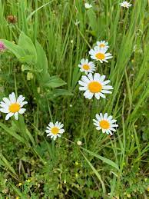

Northwest Connection Family Resources
15896 W 3rd Street
Hayward WI 54843

