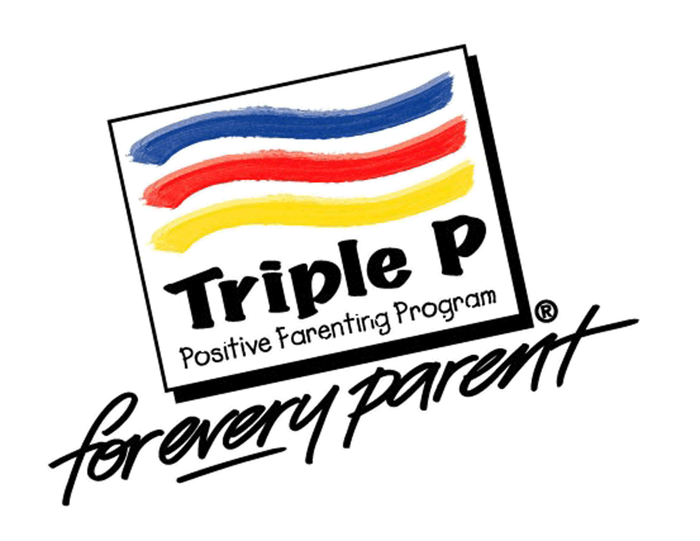
Triple P Workshop: Coping with Stress

Have you ever felt that you cannot take on one more task or activity?
Have you ever felt that stress is interfering with your parenting?
Come learn how to use positive parenting strategies while managing day to day stress.

When: December 16th, 2021
Where: Zoom (Link will be sent day of workshop)
Time: 5:00 – 6:30 pm
To register, click on the link attached to this post or call
(715) 634-2299 by Friday, December 10th, 2021.

