Northwest Connection Family Resources
Virtual Spring Tribal Conference with Jason Rahn
Thursday evening & Friday March 4 & 5, 2021
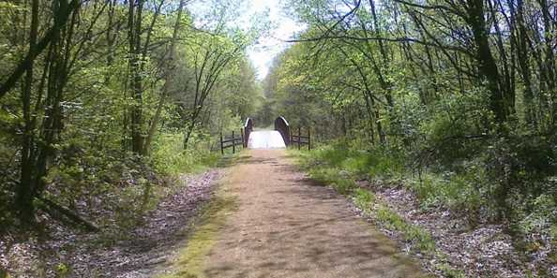

Connecting with each other…
to better connect with
the children and families in our programs.

Session 1 – Thursday, March 4, 2021 6:00 pm – 8:00 pm
Autism: What is it exactly and how can I help support a child’s needs?
It is so important that you enter into any situation with information that is factual and functional. In this first section, we will discuss the current facts about Autism, including the medical and education definitions of Autism, the main characteristics that make up autism, and finally how this information can inform your understanding of child development and appropriateness.
Session 2 – Friday, March 5, 2021 10:00 am – 12:00 pm
Challenging Behaviors: Understanding a child’s behavior and tips/tools you can use to respond effectively and empathetically.
In this session, we will learn about a variety of evidence-based practices you can use within your program to support a child’s varied needs and respond effectively to their challenges. As we know, behaviors are often a means of communication, so the real question becomes, “What are they trying to say and how can we help them say it more appropriately?”
Session 3 – Friday, March 5, 2021 1:00 pm – 3:00 pm
Difficult Conversations: Learning to talk with parents about a child’s development and/or behaviors.
One of the most difficult things you, as a teacher, will have to do is talk with a parent(s) about their child’s development, and more specifically, about their atypical development. How do you tell a parent their child is not able to do the things they should be doing for their age? How do you tell a parent their child bit or hit another child? In this final session, we will talk about the importance of honest relationships (from the very beginning) and best practices for having difficult conversations.

Jason Rahn is the Inclusion Policy Analyst for the Bureau of Early Learning and Policy at the Department of Children and Families (DCF). Jason works with and provides support to Wisconsin’s Technical Consultants and CCR&R’s around both YoungStar and the inclusion of children with special needs in child care programs. Jason worked for 12 years as an Early Childhood Special Education teacher in Minnesota and West Virginia and was a family advocate for the organization ARC where he also developed and implemented a training program that helped parents understand their rights under the Individuals with Disabilities Education Act. Finally, and most importantly, Jason was the parent of a child with a disability. Jack was the starting point to the journey that has brought Jason to where he is today.
Northwest Connection Family Resources
Virtual Spring Tribal Conference with Jason Rahn
Thursday evening & Friday March 4 & 5, 2021
This conference is being offered FREE of charge to:
- Tribal child care providers throughout Wisconsin
- Child care providers/early childhood educators in the NCFR service delivery area.

Others may attend with a registration fee of $25.00 (no refunds will be given)

To ensure you receive the zoom link and conference information please register by February 24, 2021. One registration per person. (Please make copies if needed.)

Name________________________________________________________________
Program or School District_______________________________________________
Address__________________________________County/Tribe_________________
City_____________________________________ State _________Zip ____________
Phone ______________________Email _____________________________________
Registry # ____________________ OR birthdate _______________ & last 5 digits of your social security number__________________(required to complete registration)
Are you participating in YoungStar? ____________ YoungStar rating: ____________
I WILL BE ATTENDING (please check): All 3 conference sessions _______________
Session 1 _________ Session 2 ___________ Session 3 ____________

Please send your completed registration form to the address below or email it to nwconnection@ncfrwi.net. To pay for registration, please include your payment or call (800) 733-KIDS or (715) 634-2299 for Paypal information.
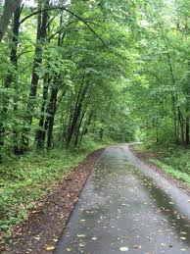
Northwest Connection Family Resources
15896 W 3rd Street
Hayward WI 54843

Funding and support provided by the Wisconsin Department of Children and Families & Supporting Families Together Association

