Northwest Connection Family Resources
Virtual Spring Rural Conference with Angel Stoddard
March 2021

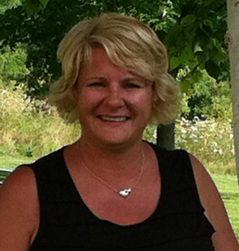
Angel Stoddard, MS is driven by a deep belief that all leaders (and teachers are leaders) must be learners and aims to inspire the joy of learning in others. She strives to elevate the role leader’s hold in ensuring quality programming. Her mission each day is to show up with passion and purpose, with curiosity and courage. In her role as full-time instructor for the University of Wisconsin – Milwaukee’s Center for Early Childhood Professional Development and Leadership, Angel designs, develops and presents professional development opportunities for local, state, and national audiences. Most recently, Angel was recognized as an Exchange Leader.

Session 1 – Tuesday: March 16, 2021 6:30 pm – 8:30 pm
Intentional Teaching
Every activity with children has a purpose. Each piece of equipment or the materials has a reason. Your purpose and reason behind it all is to offer experiences so children can practice and development skills necessary for success. Whew! That’s a mouthful! This workshop will break down the teaching cycle to assist teachers in creating meaningful and intentional learning opportunities. Along the way we’ll engage in discussions and activities as well as answer questions and find solutions.

Session 2 – Tuesday: March 23, 2021 6:30 pm – 8:30 pm
Explaining Play to Parents – and other adults!
“She plays at home, when she’s here I want her to learn.” “Why aren’t you teaching him the alphabet and how to read?” If you hear these or similar questions from parents (or other adults) and aren’t quite sure how to answer, this inspiring workshop is for you. Leave with practical ways to show and explain why play is critical to child development. They’ll be praising your play efforts…almost guaranteed!

Session 3 – Tuesday: March 30, 2021 6:30 pm – 8:30 pm
WMELS and Nature
Children love to be outside. They love to play with sticks and rocks and boxes. How can teachers intentionally plan using natural materials to support each child’s individual growth and development, even in an urban setting? Asphalt and gravel? No worries! Together we’ll find ways to weave nature into your daily curriculum, both indoors and out. We’ll link natural materials to support growth in each Wisconsin Model Early Learning Standards (WMELS) domain. Focus is primarily for teachers of older toddlers and preschool, and who are familiar with the 5 WMELS domains.

Northwest Connection Family Resources
Virtual Spring Rural Conference with Angel Stoddard
March 2021
To ensure you receive the zoom link and handouts please register by March 5, 2021.
Registration Fee: $25 One registration per person. (Please make copies as needed.)
This conference is FREE, to 4 & 5 YoungStar rated programs, in the NCFR service delivery area.

Name________________________________________________________________
Program or School District_______________________________________________
Address__________________________________County/Tribe_________________
City_____________________________________ State _________Zip ____________
Phone ______________________Email _____________________________________
Registry # ____________________ OR birthdate _______________ & last 5 digits of your social security number__________________(required to complete registration)
Are you participating in YoungStar? ____________ YoungStar rating: ____________

I WILL BE ATTENDING (please check): All 3 conference sessions ____________
Session 1 _________ Session 2 ___________ Session 3 ____________

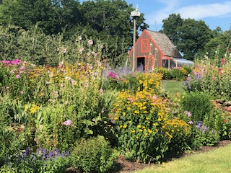
Please send your completed registration form to the address below with your payment or email it to nwconnection@ncfrwi.net and receive PayPal payment information.
Northwest Connection Family Resources
15896 W 3rd Street
Hayward WI 54843

Funding and support provided by:
Wisconsin Department of Children and Families &
Supporting Families Together Association

