JOIN NORTHWEST CONNECTION FAMILY RESOURCES FOR AN EVENING WITH…….

Lisa Murphy aka: the Ooey Gooey Lady!

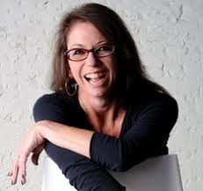
Lisa was scheduled to present at this year’s annual NCFR Fall Conference. Due to COVID-19 Lisa’s in-person presentation has been postponed until October 16, 2021. (Be sure to SAVE THE DATE) As a kick-off for next year and so we aren’t all so unhappy about not being together this fall Lisa will be virtually presenting…

CIRCLES ARE FOR SQUARES
October 12, 2020
6:30 – 8:00 pm

Considering a Circle Time Sandwich - this is not another “things to do at circle time” workshop. Actually, this session will question why we are doing circle time in the first place. Lisa asks a very direct question: Why do we interrupt engaged children to come to a meeting? And if we are going to bring them to the carpet for a meeting, it better be a darn good meeting! Using a “circle time sandwich” metaphor, she offers ideas for all of the possible “sandwich fillings” yet, in this session, focuses mostly on the metaphorical filling of books and stories. Modeling what she means by organic enthusiasm, Lisa will share examples of “good” children’s books throughout the entire session. She might read some of them too!

Lisa Murphy has been involved with early childhood education for over 20 years; teaching and working with children in various environments including Head Start, kindergarten, private preschools, family childcare, park and rec centers, group homes and many child care centers.

Lisa is the founder and CEO of Ooey Gooey, Inc. where her mission is to assist in the transformation of the industry of early childhood education by offering 1) the best workshops and trainings; 2) the most up to date materials and resources; and 3) insightful conversations and connections through the power of social media. Lisa presents hundreds of workshops each year to both domestic and international audiences on various topics related to early childhood education.

(Registration will be accepted until October 7, 2020 or until the training is full)
What to expect: The day of the training a zoom link will be emailed to you, to connect to the training. One zoom link is required per participant.
Participants will need to sign in to the chat box.
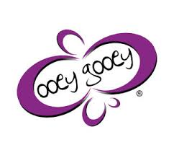
Only registered participants successfully completing the training will receive Registry hours.

SAVE THE DATE: October 16, 2021

Lisa Murphy, M.Ed will be joining us in-person at the NCFR Annual Fall Conference held at the Hayward Wesleyan Church. Watch for registration information next summer.
-------------------------------------------------------------------------------------------------------------------
Lisa Murphy - CIRCLES ARE FOR SQUARES
October 12, 2020 6:30 – 8:00 pm
Cost: $15.00

To Register: Email nwconnection@ncfrwi.net or call (800) 733-KIDS

Name: __________________________________________ Registry # ____________________

Program Name: ___________________________________ Phone # ____________________

Address: ____________________________________ County/Tribe: _____________________

Email: ______________________________________ YS rating: _____________________
Payments can be mailed to: Want to pay for your training online?
Northwest Connection Family Resources (NCFR)
15896 W 3rd Street
Hayward, WI 54843
We can Request or Invoice Payments.

