Northwest Connection
CHILD CARE PROGRAM
BUSINESS INFORMATION FORM

Date Completed: _______/_______/___________

Completed By: ________________________________________________

Family Resources

General Information

Name: ______________________________________________________ Title: _______________________

Business Name: __________________________________________________________________________
Northwest Connection Family Resources will release your program name and information to families seeking child care by mail and through online referrals unless you instruct us otherwise.

If you do not want your name to be released at this time, please indicate here:  “No”

You may call at any time to have your program included in the referral list.
Please complete this form for statistical purposes.

Location Address: ________________________________________________________________________

City: _____________________________ State: _________ Zip: _____________ County: ______________

Phone # 1: ________________________Ext.________ Phone # 2:_______________________Ext._______

Fax: ___________________________ Website: __________________________________

Internal E-Mail (to be used for Childcaring emails only):______________________________________________

Referral Email: (to be listed on child care referrals): ________________________________________________

Mailing Address (if different from above):_______________________________________________________

City: _________________________________________ State: ______________ Zip: ___________________

Ages of Children Served

Age of the youngest child you are willing to care for: _______ weeks _______ months _______ years

Age of the oldest child you are willing to care for: _______ weeks _______ months _______ years

Language Languages spoken by you or your staff (check as many as apply)

English American Sign Language Hmong
Spanish Arabic Other (please list) _____________

Special Needs Training or Experience
Caregiver(s) have had training or experience with the following (check all that apply)

Emotional/Behavioral Disability (i.e. ADD/ADHD, Autism) Feeding Tube
Physical Disability (Cerebral Palsy, Spina Bifida, Seizures) Administer Shots
Cognitive Disability (Down Syndrome, Mental Delay) Food Allergies
Sensory Disability (Hearing/Visual Impairment, Comm. Disorder) Allergies or Asthma
No training in any of these areas
*All providers have an obligation to reasonably accommodate children with disabilities in their programs.

Schedule Information
Days of Operation | Start Time | End Time | Preschool Options  Offer AM Preschool Hours____________  Offer PM Preschool Hours____________  Offer AM 4K Hours_____________  Offer PM 4K Hours_____________
Monday
Tuesday
Wednesday
Thursday
Friday
Saturday
Sunday

Types of schedules/programs available (check as many of the following as apply)
Accepts Children: Full Time
Part Time Care for Children Under 2 Years of Age
Part Time Care for Children 2 Years of Age or Older
Duration: Full Year School Year Summer

Extra Care Services:
Drop In (4 hrs or less on limited time basis)
Before School
Rotating (care changes week to week)
Temporary/Emergency
After School
24 hours (must be regulated for full 24 hrs)

Open holidays (such as Thanksgiving, Christmas, etc.) Sick Care (children who are mildly ill or recuperating)

Indicate your rates:

Age Group | Hourly | Hourly | Daily | Daily | Weekly | Weekly | Monthly | Monthly
(Age Range) | Part Time | Full Time | Part Time | Full Time | Part Time | Full Time | Part Time | Full Time
0-11 months
1 year
2 year
3 year
4 year
5 year
6+ years
Before School
After School

When serving children that receive Wisconsin Shares, do you just accept the maximum county reimbursement?

Yes No

Additional Fees (check as many of the following as apply)

One Time Enrollment Fee Yearly Registration Fee Security Deposit
Meal/Snack Fee Supply Fee Ask Provider
Transportation Fee Holding Fee
Late Pick-up Fee Activity/Field Trip Fee

Financial Assistance In addition to enrolling children receiving the state’s Child Care Subsidy, your program offers the following types of financial assistance for families. (Check as many as apply):

No Financial Assistance Sliding fee scale
Scholarships Family discount (discount for more than one child per family)

Public Elementary School(s) your program is assigned to __________________________________________

Vacancies
This information is provided to families seeking child care.
Date of earliest vacancy _____________________

Total Vacancies: 0-23 months_________________
Total Vacancies: 2+ years____________________

This is an example of vacancy information provided to families.
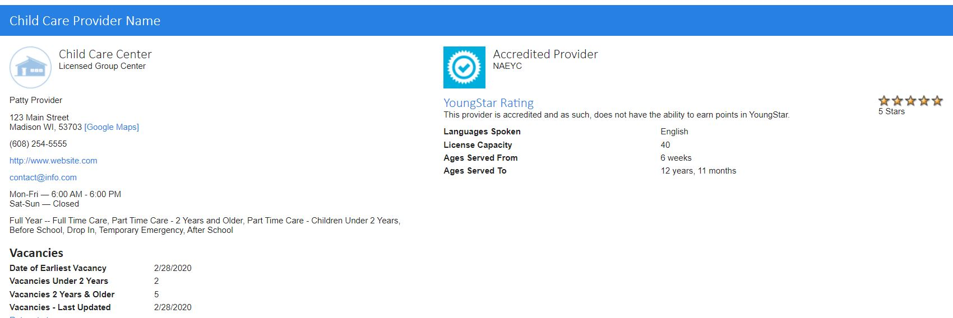
Expulsion Questions
In the last 12 months, how many children have been asked to leave your program for the following reasons:
Inability to Pay. ________________
Inability to meet the needs of the child (developmentally or emotionally). ________________
Conflict between the parent(s) of the child and a staff member of the program. ___________

The following vacancy information will be used for reporting purposes only and will not be individually identifiable.
Open Vacancy Section
How many children in each age group could you enroll today?

Full time is more than 20 hours/week.
Part Time is 20 hours or less/week.
 | Full Time | Part Time
0-11 months
1 Year
2 Years
3 Years
4 Years
5 Years
6+ Years

TOTAL VACANCY SECTION
As of today, how many total vacancies do you have for each age group?

Full time is more than 20 hours/week.
Part Time is 20 hours or less/week.
 | Total Full Time Vacancies | Total Part Time Vacancies
0-23 months
2+ Years

Enrollment Information
Please complete the following program enrollment chart with the number of children enrolled today. Include your own children that are enrolled, if applicable.
Enrollment
 | Full Time | Part Time
0-11 months
1 Year
2 Years
3 Years
4 Years
5 Years
6-8 Years
9+ Years

Census Bureau (Optional, for statistical purposes only)
Number of persons on staff whose race is:
(Include yourself in the count)

_____White _____Hmong
_____Hispanic or Latino _____Asian (besides Hmong)
_____Black or African American _____Two or More Races
_____American Indian _____Other race (indicate race) ______________
_____Southeast Asian

Family Child Care Provider Benefits (Check all that apply)

Paid Vacation Days Paid Sick Days Health insurance

Wage & Benefits for Group Center Staff

Benefits (Check all benefits currently offered by your program)

Health Insurance Dental Insurance
Paid Family Leave Paid Holidays
Paid Vacation Days Paid Sick Days
Paid Preparation/Planning Time Paid Staff Meetings/In-services
Continuing Education Reimbursement Reduced Child Care Rates

Wage Information

Position1
(Please circle one): Director, Assistant Director, Program Coordinator, Lead Teacher, Assistant Teacher, Substitute, Site Supervisor, Group Leader

Lowest Hourly Rate of Pay:____________ Highest Hourly Rate of Pay:____________

Position2
(Please circle one): Director, Assistant Director, Program Coordinator, Lead Teacher, Assistant Teacher, Substitute, Site Supervisor, Group Leader

Lowest Hourly Rate of Pay:____________ Highest Hourly Rate of Pay:____________

Position3
(Please circle one): Director, Assistant Director, Program Coordinator, Lead Teacher, Assistant Teacher, Substitute, Site Supervisor, Group Leader

Lowest Hourly Rate of Pay: ____________ Highest Hourly Rate of Pay: ____________

YOUR PRIVACY RIGHTS

Our mission is to provide parents with objective information about child care programs in their community and information on selecting quality child care. Northwest Connection Family Resources does not endorse or recommend any particular child care program. Parents are strongly encouraged to visit each site and ask questions about policies and procedures of the program before making a final decision. We will not guarantee that you will receive prospective parents from Northwest Connection Family Resources. We encourage you to continue to advertise through local newspapers, church and other organizations. We ask that you notify Northwest Connection Family Resources of any vacancies or changes in your program (hours of operation, phone number, address, etc.)

The purpose of collecting the information in this form is to:
- Effectively provide referrals to parents who are looking for child care and provide appropriate program information.
- Report and gather statistics on child care needs.
- Provide training and technical assistance to meet your needs as a child care provider.

You are not required to provide this information, but without it, we will not be able to help parents locate your program. In addition, the information is used for statistical reporting that influences planning, policy development, and funding levels. Statistical information never includes provider names, and may be shared with community groups, etc. At times, we receive requests for a mailing list of providers from outside sources that have a legitimate provider interest, such as a public health alert, etc. This information (name, address) is public information. Other information about your program is not provided to outside vendors.

This notice covers all changes you make in your file (by phone, in person, written, or online) until your file is deleted from the database. I authorize the information in this form to be used as outlined above.

Signature: _________________________________________________ Date: ____________________

PLEASE RETURN THIS FORM TO:

Northwest Connection Family Resources
15896 W 3rd Street, Hayward, WI 54843

715.634.2299 OR 800.733.KIDS

Ashland, Barron, Bayfield, Burnett, Douglas, Florence, Forest, Iron, Oneida, Price, Rusk, Sawyer, Washburn, Vilas Counties
Bad River, Forest county Potawatomi, Lac Courte Oreilles, Lac du Flambeau, Red Cliff, Sokaogon and St. Croix Tribes

Non Profit Org
U.S, Postage Paid
Hayward WI
Permit #64

15896 W 3rd St.
Hayward, WI 54843
Phone: (715) 634-2299 & (800) 733-KIDS
Fax: (715) 634-8743

Website: www.wisconsinchild.org

RETURN SERVIC REQUESTED

Office Hours
Monday-Friday 8:00am – 4:00pm Like us on Facebook

IT’S THAT TIME AGAIN…….
BUSINESS INFORMATION FORM
ENCLOSED!

Please call us if you have any questions:
800-733-KIDS or 715-634-2299

