

# April is National Child Abuse and Neglect Prevention Month Please join us for: Bringing the Protective Factors to Life in Your Work!

**NORTHWEST CONNECTION**

**FAMILY RESOURCES**

The 5 Protective Factors:

1. **Social and Emotional Competence of Children**
2. **Knowledge of Parenting and Child Development**
3. **Social Connections**
4. **Parental Resilience**
5. **Concrete Supports in Times of Need**

As part of our mission to support families and healthy development of children, we are offering this training **FREE** of charge. During this training, we will engage in a comprehensive discussion about the importance of bringing the Protective Factors to the forefront of the field of family support. You will leave with a renewed sense of purpose and enthusiasm for your work!

Please call 800-733-KIDS or (715) 634-2299 to register, no later than April 3, 2020. Registration is limited.

**For professionals in:**

* family support
* social services
* child welfare
* public safety
* probationary work
* education services
* social work
* healthcare

Small but significant changes…

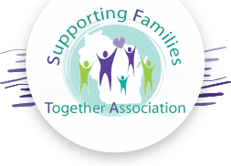

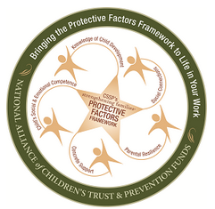

## Sevenwinds

## Convention Center

## April 8& 9, 2020

## 8:30 am-3:00 pm

## FREE OF CHARGE

## Lunch included

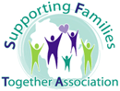

Northwest Connection Family Resources

15896 W. 3rd St

Hayward, WI 54843

Ph: 715-634-2299

www.theparentingplace.net