Northwest Connection Family Resources
invites YOU and YOUR family
to join us for our annual
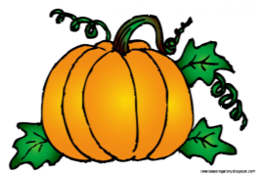
Pumpkin Painting Party
Tuesday, October 29
5:00 pm-7:00 pm

Come bring your family and join the fun as we paint pumpkins, eat a light supper and enjoy some sweet treats.
All necessary supplies will be provided FREE of charge.

Please call (715) 634-2299 Northwest Connection Family Resources by Thursday, October 23 if you plan to attend so enough pumpkins and supplies can be ordered.
Northwest Connection Family Resources
15896 W 3rd Street
Hayward WI 54843

