FREE FAMILY MOVIES
Saturday December 7, 2019
Hayward Cinema 4
Showtime: 9:00 am and 11:00 am

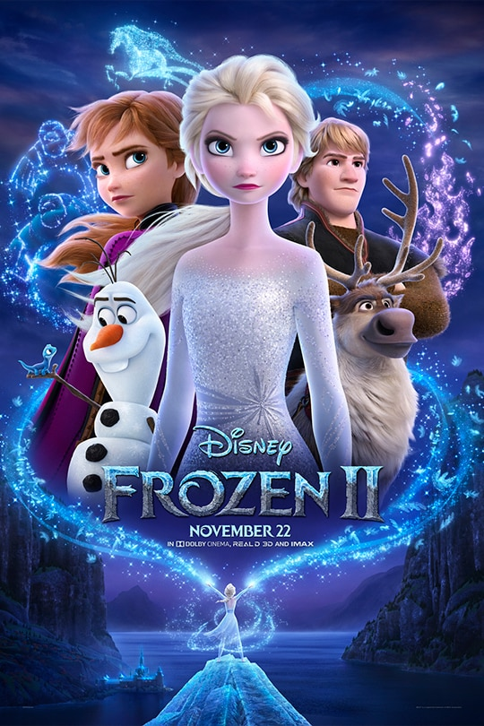
Both movies
will be shown
at each of the times listed above!

Doors open
at
8:30 am.

FOR MORE INFORMATION CALL: Northwest Connection Family Resources 715 634-2299
Sponsored by:
Northwest Connection Family Resources
LCO Mino Maajisewin, LCO EHS Father Out Reach

