25th Annual Fall Conference
Northwest Connection Family Resources


Every
Child
Needs
A
Hero!

October 19, 2019 8:30 am – 4:00 pm
Wesleyan Church
10655 State Rd 77 Hayward WI 54843


EVERY CHILD NEEDS A HERO!

9:00 - 9:15 Welcome
Introduction of staff
Prize Patrol

9:15 - 10:30 Keynote

Becoming an Autism Hero!
Learning, Understanding, Supporting and Inspiring
Jason Rahn
Autism. This relatively simple word tends to bring with it a whole lot of baggage. Whether it is the assumptions we make or the stereotypes we have come to rely on, the end result is the same: confusion and fear. “I don’t think this child will fit in with the other kids.” “I don’t have someone who can be with them all the time.” “What happens if they get upset or have a meltdown?”

Well, have no fear. You’ll be an Autism Hero before leaving here! (Cheesy, I know, but hang in there)
Surprisingly, being a true Autism Hero is easier than you might think. In this first keynote session, you will begin your transformation into an Autism Hero by strengthening the most important muscle you have, your brain. It is so important that you enter into any situation with information that is factual and functional. Together, we will discuss the current facts about Autism, look at the medical and education definitions of Autism, and see how this information can inform your understanding of child development and appropriateness.

Within this first session, you will also acquire the ability to focus your vision on the true meaning behind a child’s behavior or action. We will look at the main characteristics that a child with Autism may display and learn how to use your (super) power of perception and awareness to understand why a child may be responding in a particular way.

My name is Jason Rahn and I work for the Department of Children and Families (DCF) as an Inclusion Policy Analyst in the Bureau of Early Learning and Policy. This long title simply means that I have the pleasure of working with and providing support to Wisconsin’s Technical Consultants and CCR&R’s around both YoungStar and the inclusion of children with special needs in child care programs.

Before coming to DCF, I worked for 12 years as an Early Childhood Special Education teacher in Minnesota and West Virginia. I have also worked for the organization ARC as a family advocate, as well as I developed and implemented a training program that helped parents understand their rights under the Individuals with Disabilities Education Act. Finally, and most importantly, I was the parent of a child with a disability. Jack was the starting point to the journey that has brought me to where I am today.


Session 1 10:45-12:00

What is technology doing to our children/families/society? Linda DeMoe
This workshop will look at the good, the bad and the ugly of technology. How young is too young to give my child a tablet? How long is too long to be on the computer? My time on cell phone isn’t affecting my family, is it? We’ll be looking at all aspects of how technology is changing our world.

The “Super” Power of Infants Katie Harder and Shannon Saffert
Infants start interacting from the time they are brought into this world. For infants, play is not just about the toys, it’s about the interactions with their family, caregivers, and peers. When parents and caregivers engage in play activities with their infants like peek-a-boo or filling a box with objects to dump and fill again, they’re helping children expand on every stage of development. Come learn about activities and how each encourages developmental advancement with newborns to 12 months.

Celebrations and Holidays in Early Childhood Programs Nora Ziburski
Celebrations and holidays are a common occurrence in most Early Childhood programs. Join us as we consider NAEYC recommendations, discuss ways to make all children and families represented, and share with each other strategies and examples of celebrations and holidays in our ECE programs.

Stay Calm and Teach On! Brandy Metcalf & Amanda Linden
Have you ever had one of those days? The workshop will give teachers techniques and ideas on how to keep a calmer classroom. We will discuss ways to keep calm, cool and consistent.

Early Literacy Robin Mainhardt and Brenda Flannery
The Early Literacy training will examine the key components of a comprehensive, integrated literacy program and teaching strategies that encourage strong phonological awareness. We will examine the effectiveness of current practice using program assessment tools. We will begin to implement training content by planning for an engaging literacy environment filled with high quality children's literature. This is part 1, part 2 will continue at 2:30-3:45 pm.

Making Circle Time Engaging Jessie Millington and Lisa Cottrell
In this session, we will demonstrate effective and purposeful strategies that increase active engagement and reduce challenging behaviors during large group activities. The strategies that we will discuss will increase fun, engagement, and learning through effective routines and other essential elements; such as visual aids to promote all children’s participation, and independence.

1:00 – 2:15 KEYNOTE

The Heart and Hands of a Hero
Jason Rahn
In the first keynote session, you strengthened your mind and your vision (how you see a situation or behavior), two foundational areas necessary for supporting the more hands-on qualities of an Autism Hero. Now that you have a strong base on which to begin building, it is time to add your hands and heart to the equation.

In the second keynote, your training will focus on working the arms and biceps so you will be able to lift and support every child in your program. You will learn about a variety of evidence-based practices that you can use within your program to support a child’s varied needs and respond effectively to their challenges. As we know, behaviors are often a means of communication, and this is no different for a child with autism. The real question becomes, “What are they trying to say and how can I help them say it more appropriately?”

Finally, you will work on strengthening the power of your heart. It is too easy to let a child’s challenging behaviors overshadow your ability or willingness to recognize the positive moments that are incredible and inspiring. A true Autism Hero sees the whole child, their strengths and their needs, and is able to support them in ways that are empathetic, understanding and appropriate.

Do you have the heart and the hands of a hero?
You do now!

A little bit about more about Jason Rahn:
Jason was excited to come up north to share some of his knowledge, experience, and humor with all of us during the fall conference,
“Every Child Needs a Hero”.


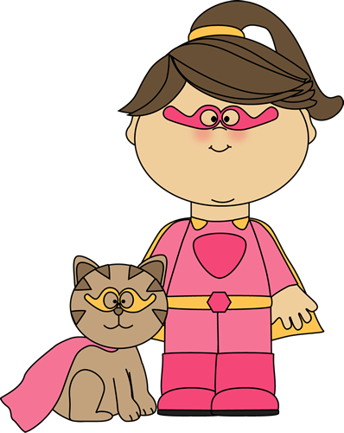


Session 2 2:30 – 3:45
Being Successful in Your Professional Development Journey Anna Hanson
Is it possible to work, go to school full time, and take care of children? Anna from Annas Bananas did it! You will learn some small, yet BIG, tips on how to manage the daily grind but still be successful in your professional development journey while still working in childcare. She will share ideas on finances, support systems, time management, answer questions and give you insight on what your journey may look like. Join Anna as she shares her journey!

It’s More Than a Just Piece of Wood. Introducing Children to Woodworking. Cindy Gillett
It is never too early to introduce children of a young age to woodworking. It is a life skill and is often passed down through generations....making our forefathers SUPER Heros! We will explore tools (non-power) learn how to use them safely, create a birdhouse recipe holder, a pin/magnet using wood circles, and a birdhouse cupcake. Handouts will be provided. This class is limited to 20.

Having the Power to Make Your Outdoor Environment Super! Samantha McHugh
Creating a safe, engaging and developmentally appropriate outdoor learning area for infants to school-agers. Learn how your environment can encourage children to explore, be active, use their “super” senses and develop a variety of skills in all seasons.

Got Music? Jennifer Thomas Music is a part of every culture and every child’s life. In this session we will explore how to bring music to the classroom with intention and purpose. We will discuss why music is vitally important and how to connect developmental domains to music activities. We will talk about ways to introduce songs and instruments as well as brainstorm different ways of movement in the classroom.
Part 2 - Early Literacy Robin Mainhardt and Brenda Flannery

The Early Literacy training will examine the key components of a comprehensive, integrated literacy program and teaching strategies that encourage strong phonological awareness. We will examine the effectiveness of current practice using program assessment tools. We will begin to implement training content by planning for an engaging literacy environment filled with high quality children's literature.

Active Play Throughout the Day Lisa Cottrell and Jessie Millington
Exercise creates an environment in which the brain is ready, willing, and able to learn. As adults, we should be promoting a healthy lifestyle on behalf of the children in our care by making sure they are eating well and playing hard. This training is set up to get you up and active with activities that are easy, and inexpensive to assemble and include supplies that you will likely have on hand. They are also adaptable to match all ages and abilities of the children in our care.

Read about all the choices for a fun day!

Saturday October 19, 2019
8:30 Registration and Continental Breakfast

8:30 Silent Auction

9:00 – 9:15 Welcome/Announcements in the Main Room

9:15 – 10:35 KEYNOTE
Every Child Needs a Hero! Jason Rahn

10:45 – 12:00 SESSION 1
What is technology doing to our children? Our families? Our Society? Linda DeMoe
The “Super” Power of Infants Katie Harder and Shannon Saffert
Celebrations and Holidays in Early Childhood Programs Nora Ziburski
Stay Calm and Teach On! Brandy Metcalf & Amanda Linden
Early Literacy Robin Mainhardt and Brenda Flannery
Making Circle Time Engaging Jessie Millington and Lisa Cottrell


12:00 – 1:00 A LUNCH FIT FOR A HERO

1:00 – 2:15 KEYNOTE
The Heart and Hands of a Hero Jason Rahn

2:30 – 3:45 SESSION 2
Being Successful in Your Professional Development Journey Anna Hanson
It’s More Than a Piece of Wood. Introducing Children to Woodworking. Cindy Gillett
Having the Power to Make Your Outdoor Environment Super! Samantha McHugh
Got Music? Jennifer Thomas
Part 2 - Early Literacy Robin Mainhardt and Brenda Flannery
Active Play Throughout the Day Lisa Cottrell and Jessie Millington

2:30 Silent Auction Ends
3:45 – 4:00 Announcements and prizes in the Main Room

SILENT AUCTION: The silent auction is your opportunity to find some amazing new things for your program. The auction is all about the challenge of getting the best deal ever and have some fun! Look everything over and decide what you are willing to pay for the item. Write it on the slip of paper and put it in the container. The bidding is throughout the day and ends at 2:30 pm. Kathy will check to see who has the highest bid. Make your bid count! If you have the highest bid, it is yours!

VENDORS: We encourage you to visit the vendors. There will be many items for you to choose from. The choice will make you excited, as you find things for your programs. Children love new things and new ideas! NCFR tries to bring some new vendors to the conference each year, but we are always delighted to have our regular vendors back again. There are some amazing new things on the market to give your environment a new look. Pick up a catalog to find new toys and games for your little ones to enjoy! Our YoungStar Consultants can help you with suggestions.

We always connect the Week of the Young Child activities to the “EVERY CHILD NEEDS A HERO!” conference. You will have an opportunity to win an amazing prize for your program. Throughout the Week of the Young Child you participated in activities, took pictures, charted favorite things, read books, prepared snacks, and discovered what a hero is. Create a poster to highlight all the fun you had in celebrating the heroes in your classroom. There will be 4 prizes awarded for WOYC- Every Child Needs a Hero for the following categories: 1) participating in the week's suggested activities 2) Most creative additional WOYC activities, 3) parent/child involvement 4) random drawing.

This is your opportunity to share the fun you had and show off your program.

LODGING: Looking for a place to sleep, to be well rested for all the fun? A block of rooms has been reserved at the Holiday Inn & Suites (formerly Comfort Suites), call 715 634-0700 to make your reservation. Be sure to request the block under Northwest Connection Family Resources.

DIRECTIONS:
Holiday Inn & Suites – At the intersection of Hwy 63 & 27, turn south on 27. You will pass McDonalds, cross the bridge, at the stop lights go left on B. Holiday Inn will be on the left after the Lumberjack Bowl. The address for Holiday Inn is 15586 County Road B.

Hayward Wesleyan Church – At the intersection of Highways 63 & 27/77, turn west on Hwy 27/77. Drive approximately ½ mile. The Church will be on the left. If you are coming from Minong, the Church will be on right. The address for Hayward Wesleyan Church is 10655 Nyman Ave (if you put this address in your GPS, for some reason, it will not take you to this location).

We hope to see YOU at the 25th Annual Fall Conference. This is a day we planned just for YOU! We want you to have an extra special day. NCFR appreciates all you do for children and families.

Northwest Connection Family Resources Non-Profit Org
. U.S.Postage Paid
15896 W 3rd Street Permit #64 Hayward WI 54843
Phone: (715)634-2299
Fax: (715) 634-8743 RETURN SERVICE REQUESTED
Email: nwchild@cheqnet.net

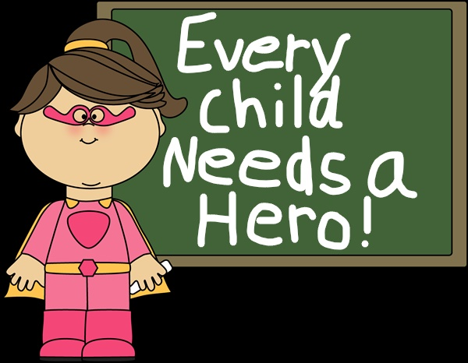

October 19, 2019 – Hayward Wesleyan Church

Register by September 20, 2019 to be entered into a drawing for a prize!



EVERY CHILD NEEDS A HERO!
Saturday, October 19, 2019
Please fill out the registration, mail it with your check to:
Northwest Connection Family Resources
15896 W 3rd Street Hayward WI 54843
800 733-KIDS

9:15–10:35 KEYNOTE (everyone)
Becoming an Autism Hero! Jason Rahn

10:45 – 12:00 SESSION 1 (Choose one session from the list)
_____________________________________________

1:00 – 2:15 KEYNOTE (everyone)
The Heart and Hands of a Hero Jason Rahn

2:30 – 3:45 SESSION 2 (Choose one session from the list)
______________________________________________

Register by September 20 to be entered into a drawing for a surprise!
$35.00 early registration: by September 20. $35.00 registration: after September 20.
One registration form per person. Please copy, if more forms are needed for staff. Sorry no refunds.

Name ______________________________________________________________________________
Program name________________________________________________________________________
Please check one:
Certified ____ Family____ Group Center_____ School-Age____ 4K____ Head Start____ Other ____
Address _________________________________________County/Tribe__________________________

City________________________________________ State________________ Zip __________________

Phone _____________________________ Email _____________________________________________

Please check your program’s YoungStar rating:
____5 Star ____4 Star ____3 Star ____2 Star ____2 Star automated ____Non Participating

