***Northwest Connection Family Resources***

**Spring Tribal Conference**

**LCO Sevenwinds Lodge & Conference Center**

**13767 W County Road B Hayward WI**

**Friday April 12, 2019**

**8:30 am – 4:00 pm**

**Working with Substance Abusing Families**

**Terry L. Cross**

Have you ever wondered how YOU can support families who are struggling with substance abuse? This conference is for YOU!

Parental substance use disorders are a significant factor among First Nations families in child welfare. The presentation will provide an overview of working families with multiple substance use disorders from both a direct service and a systems collaboration point of view. Meth and opioids alone or in combination with alcohol and differences in treatment and recovery will be discussed. The presenter will discuss how to deal with this issue and how systems collaboration can make successful outcomes possible. A collaborative model that engages child welfare, the courts, and behavioral health providers, especially in cases of prenatal exposure, will be discussed. Participants will learn five essential roles for working with substance abusing families including understanding treatment and how their

work can be accomplished through partnering on the parent’s recovery.

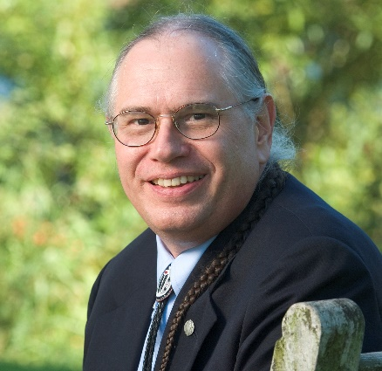Terry (Ha-ne-ga-noh), an enrolled member of the Seneca Nation, received his master’s degree in social work from Portland State University in Portland, Oregon. He is the founding Executive Director of NICWA (National Indian Child Welfare Association), now serving as senior advisor. He is the author of Positive Indian Parenting and co-authored Towards a Culturally Competent System of Care, published by Georgetown University. He has 40 years of experience in child welfare, including 10 years direct practice.

**Spring Tribal Conference April 12 Sevenwinds LCO Convention Center**

**Registration $25.00** *(sorry no refunds)*

**Please fill out the form below and mail it with your check to:**

**Northwest Connection Family Resources**

**15896 W 3rd Street**

**Hayward WI 54843**

**If you have any questions call 800 733-KIDS 715 634-2299**

**Lunch is included!**

**Deadline to register is March 29 to ensure we have materials for everyone!**

**One registration per person. (Please copy if more forms are needed)**

**Name____________________________________________________________________**

**Program__________________________________________________________________**

**School District_____________________________________________________________**

**Address__________________________________County/Tribe_____________________**

**City_____________________________________State________Zip _________________**

**Phone ______________________Email ________________________________________**

**Are you participating in YoungStar?_________ What is your rating?________________**

*Haven’t started your active YoungStar journey yet? Are you a 2 star automated or non-participating provider? If so, you are invited to attend the conference FREE! For more information call (800) 733-KIDS.*

***Funded by: SFTA YoungStar Diversity and Engagement***