FAMILY FUN NIGHT
ALL FAMILIES WELCOME
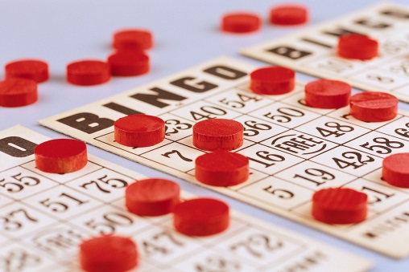
Hayward 4K Activity
Bingo & Pizza
Tuesday, January 15, 2019
5:00pm – 7:00pm
Northwest Connection Family Resources
15896 W. 3rd Street, Hayward
Come bring your family and join the fun, as we eat pizza and win prizes playing Bingo! Everything is free of charge.
Please call Northwest Connection Family Resources at (715) 634-2299 by Monday, January 14 if you plan to attend so we are sure to have enough pizza and prizes for everyone!
Sponsored by: Northwest Connection Family Resources
Hayward Community School District

